**BLOG 1- Belly Breathing (For teachers)**

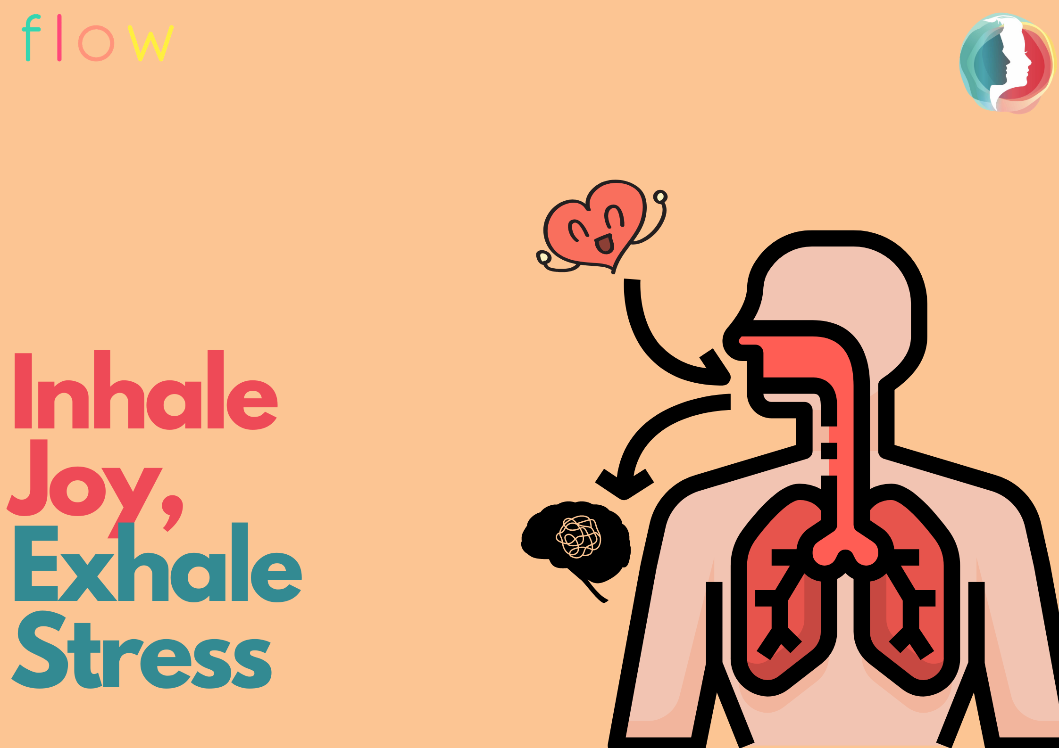

**Title: A Simple 5 Minutes Stress Buster Technique**

**Excerpt:** If you find yourself stressed often, here is a small tool to help you calm down.

When was the last time you sat down and focused all your attention on nothing but just your breath?

Life may be full of stress, tension, worries and what not! You follow your daily routine, maintain expenses, keep up with the expectations of the people around you, which isn’t always an easy task. And, at the end of the day, you find yourself on your bed to finally get some rest. But, that doesn’t relieve you from your mental tension and stress, does it?

Regardless of all the tension and worries around you, did you know, there is something that you can do to relieve you from the stress and tension of the outer world? It is a simple exercise called **‘Belly Breathing’.** Nothing too complicated, you just have to follow some simple steps and focus your attention on your breathing!

Let’s try it!

1. Sit in a relaxed position.
2. Now, close your eyes and bring your focus to your breath.
3. Notice the inflow and outflow of your breath. Observe your breath. You don’t have to control it, just observe it. What is it telling you about you?
4. Now place one hand on your chest and the other on your belly.
5. Visualise the breath flowing in from your nose going all the way down to your belly. Hold it there for 3 seconds. With each inhale, invite joy, peace and happiness into your body.
6. Slowly exhale the held breath in your belly, out from your feet and toes carrying with it all the stress, tension, anxiety or any discomfort stored in the body, slowly calming it down.
7. Repeat it till you feel charged. Allow the freshness of life in your body with each inhale and release all that is heavy with each exhale.
8. Do this for 5 minutes, then take 3 long breaths before you slowly open your eyes.

Check with yourself and see how you feel after the belly breathing exercise.

With this small activity, you can take a break from your daily routine, relaxing and recharging yourself. Doing this activity will not sway away your life problems, but it will surely help you to tackle them with a peaceful mind.

So, the next time you find yourself messed up in the doldrums of life, take out 5 minutes of your time and practice Belly Breathing!

Tags: Breathing, Diaphragmatic breathing, Exercise, mental health, Mindfulness in plain English, Mindfulness for teachers, Mindfulness for stress